**OPEN MRS:**

3. The user interface of OPEN MRS is very versatile and easy, allowing patients' information to be input and retrieved with ease. Entering either the patient ID or the name will bring up the previous information. To create a new patient record, demographic information must be submitted.

The standard distribution provides unfiltered access to the patient's healthcare records worldwide or on a larger scale.

Other distributions, such as focused distributions, on the other hand, provide patient data unique to a geographic place or to a certain ailment. Specific data for specific customers is contained in implementation-specific distributions.

4.

Benefits of an open-source approach:

• Interoperability is aided by the open approach, which allows access to clinical data.

• Allows for statistical analysis of available data and comparison of different outcomes to create appropriate forecasts.

Disadvantages:

• The threat of privacy and security is the key worry of employing an open approach

• The user interface is universal rather than specific. To get correct results, necessary functions and filters must be manually included.

• It's possible that access to the data in question will be restricted.

In my opinion, global organizations like WHO may benefit from using open source EHRs as they deal with public health worldwide.

Open MRS offers several procedures that are important for keeping track of patient records in a systematic way. Although filters can be used to get patient information, the complete data cannot be changed because Open MRS records data in a preset format.

I see that Open MRS has the capabilities to be useful. However, in addition to the standard format, the user interface should be adaptable.

These kinds of resources are very valuable for extracting data about a certain situation and making appropriate comparisons.

These are also useful in clinics with many patients to acquire, store, and retrieve patient information fast and correctly without wasting time.

**OPEN EMR:**

3. It's simple to navigate the patient's previous information. The user must fill out a complete set of information, including the insurance plan selected, for the new patient input. Such information is saved and can be used in the future.

Yes, you can generate a bill by assigning CPT or ICD-9 codes to the visit encounter.

4.

Advantages:

• Open-source aids in compiling data so that valid comparisons can be made among populations

• Provides patients with follow-up appointments so that essential preventive care can be sought.

Disadvantages:

• Filling out the patient's information on the initial visit takes time, which can be exhausting for both the physician and the patient

• Data accessibility cannot be forecast because it is open source.

Institutions concerned with global health, disease control boards, and insurance firms can all benefit from this type of EHR appeal.

Open EMR has several built-in functions that can be used to collect the majority of a patient's data. Furthermore, this method does not allow for customization.

It has the necessary capabilities for useful use, but it performs even better when customizations are added.

Open EMR is especially effective in situations when a thorough set of patient details is necessary, such as research institutions, global clinics, governmental entities dealing with health data, and so on.

I believe that Open EHR is beneficial to small and rural locations since it allows for the collection of all patient information, including insurance information, which is not possible with Open MRS.

**CDSS:**

RAMP is the app that I discovered. Clinicians and prospective medical students use this tool to generate diagnosis for a condition. It includes a variety of tools and filters for determining the condition's diagnosis.

RAMP is primarily used to provide a diagnosis and initiate the necessary treatment plan for a problem that has been defined using a questionnaire.

I believe that the information supplied can be used in conjunction with the clinician's knowledge and experience when making a diagnosis. After the physician has examined the patient clinically, a final diagnosis should be established.

It is good to use on a cell phone for easy accessibility but viewing on a larger screen is always preferred because several options can be displayed at once and navigation is easier.

RAMP is uncomplicated to use because it gives you a diagnostic once you fill out a questionnaire. In life-threatening conditions, such applications can help avoid fatality to some extent.

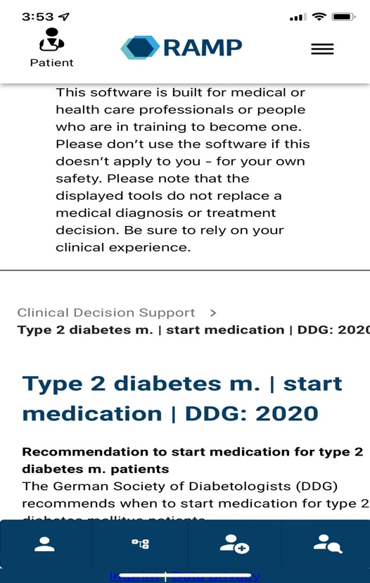

**HIE:**

IHIE provides three types of services:

• OneCare: It addresses the health concerns of individual patients.

• PopCare: This component is concerned with population health, as the name implies. Allows the doctor to track the progress of the patient's treatment, analyze the outcomes, and draw comparisons.

• GovCare: This category is focused with public health and allows for the examination of statewide data.

When it comes to physicians in the ICU or emergency room, the data in HIE assists them in gathering essential information such as vital signs, previous medical care, and test findings.

This information will help you plan the treatment you'll need.

The office staff, on the other hand, can use this information to plan follow-up appointments or services.

References:

<https://wiki.openmrs.org/display/docs/OpenMRS+Distributions>